Spartan Implementation Document

De-embedding in the S-Parameter Test

- Purpose
The purpose of de-embedding in the S-Parameter Test is to remove the effects that connectors and fixtures have on the data collected by Spartan. Currently Spartan supports the capture of formatted data which could be used to perform this operation, but in a cumbersome way for the user. The goal is to provide a user friendly way to capture or import the S2P data of a connector or fixture setup so that data processing can be done to remove the measured effects of such devices. The initial implementation of this feature will only be available for 2-port connectors and fixtures, but can be applied to any VNA supported by Spartan.

- Input
  - New Section on the Measure Tab
    - De-Embed Checkbox – This would then enable an outlined section that has an allow changes checkbox, a dropdown box of ports, a model number field, a serial number field, a dropdown box for orientation, an add button, a listbox of adapter assignments, a delete button, an up button, and a down button.
    - Allow Changes Checkbox – This will give the operator the ability to change these settings when the test step is being run.
    - Dropdown box of Ports – This will be a dropdown of port numbers. Since we currently support up to 8 ports, we will start there, but this can be expanded at a later time. When this dropdown is changed, the adapter assignments listbox will change to the adapters that are assigned to that port.
    - Model Number Field– This will where the user will enter the model number of the adapter.
    - Serial Number Field– This will where the user will enter the serial number of the adapter.
    - Orientation – This is necessary because if the adapter was measured or imported into Spartan with one orientation and will be inserted into the path in the opposite direction, the effects will change. Te user will be able to define this here.
    - Add Button – Once an adapter, orientation and a port have been selected, the user can add the association by clicking the add button.
    - Adapter Assignments Listbox – This will be a listbox that has three columns, MN, SN, and Orientation. It will list the associations of the adapters to the appropriate port that is currently selected. The order is necessary too since the calculation to de-embed the ports requires knowing the order that the signals pass through the adapters. This order will be determined by the order in which the adapters are listed in the listbox.
    - Delete Button – An association can be removed by clicking the delete button.
    - Up Button – The order of an association can be changed by clicking the up button.
    - Down Button – The order of an association can be changed by clicking the down button.

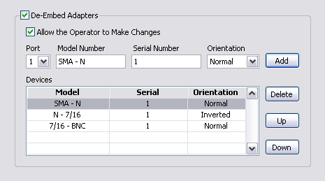

- Process
  - Applying the adapters to the test step for de-embedding.
- The user will select the De-Embed option on the test step definition panel.
- The user will select the port that the adapter will be attached to.
- The user will enter a model number and serial number of the adapter that has either been measured by or imported into the Spartan system.
- The user will select the orientation of the adapter.
- The user will add the adapter to the test step by clicking the Add button.
- The user may delete an adapter by selecting the adapter in the listbox and pressing the Delete button.
- The user may re-order the adapter by selecting the adapter from the listbox and pressing the Up and Down buttons.
- The user may change any of the properties of the association by selecting it and editing the appropriate field.
- The user will then run the test step collecting and de-embedding the data.
- If the user has been given permission to change these associations, they may during the execution of the test and then re-measuring. This will be accommodated with a button to view the current settings and the ability to change them.

- Output
Once the DUT is then tested, the SP test will apply the correct algorithms to remove, or de-embed, the effects that the connectors have on the data. The resulting data will then have the limits applied to it and then stored in the data file. Also stored in the data file will be the MN and SN of the adapters or fixtures that were removed so that in the future we could apply those algorithms in reverse to get the original data if desired. This way the data that appears on datasheets, is run through analysis, and is presented to customers will be the data that has been de-embedded.

